EXPERIMENT 4

ROLL NO: 230701304 NAME: SHALINI R K
Create a prototype with familiar and unfamiliar navigation elements. Evaluate ease of use with different user groups using proto.io

Screen 1:
Sign In page for the destination app
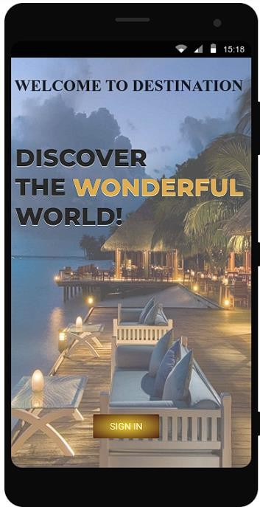
Screen 2:
Home page:

Familiar Icons:
- Hamburger Menu (☰) - Top Left:
  - A common icon representing a collapsible navigation menu.
  - Clicking it usually opens a sidebar with options like Home, Settings, and Profile.

Search Icon (🔍) - Below the Heading:
  - A widely recognized icon used for searching within the app.
  - Clicking it typically opens a search bar where users can type queries.

Three-Dot Menu (⋮) - Near "Trending Styles":
  - Represents more options or actions related to the section.

  - Often used for settings, sorting, or additional functionalities.

Possibly Unfamiliar Icons:
- Explore Button:
  - This is not an icon but a button that might lead to more details or booking options for the resort.
  - It’s common in travel and e-commerce apps but might be designed differently.

Time (08:04) - Top Right Corner:
  - This is a standard phone status display but may also indicate a feature like a time- based greeting or notification.

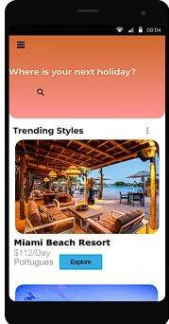
Screen3:
Resort 1 page:

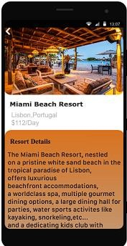

Screen4:
Resort 2 Page:

Familiar Icons:
- Back Arrow (←) - Top Left Corner:
  - A widely recognized icon used for navigation.
  - Clicking it will likely take the user back to the previous screen.
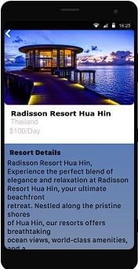

Screen 5:
Resort 3 Page:
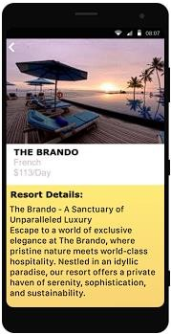

Familiar Icons:
- Back Arrow (←) - Top Left Corner:
  - A widely recognized navigation icon.
  - Clicking it will likely take the user back to the previous screen.

Time Display (08:07) - Top Right Corner:
  - A standard phone status indicator that shows the current time.
Screen 6: Profile page:

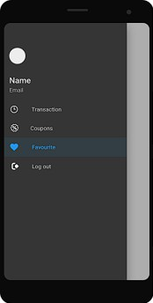

Familiar Icons:
- Profile Icon (Circle Placeholder - Top Left):
  - Represents the user's profile picture or avatar.
  - Clicking it may allow users to edit their profile or view account details.

Transaction Icon (💳 or similar) - Next to "Transaction":
  - Commonly used for payments, purchases, or financial records.
  - Clicking it likely opens transaction history.

Coupons Icon (🎟️ or Tag Symbol) - Next to "Coupons":
  - Represents discounts, offers, or vouchers.
  - Clicking it may show available coupons for the user.

Heart Icon (💙) - Next to "Favourite":
  - A universally recognized icon for saved or liked items.
  - Clicking it will likely show favorite places, hotels, or deals.

Logout Icon (⏻ or ↩) - Next to "Log out":
  - Commonly represents signing out of an account.
  - Clicking it will log the user out of the app.
Screen 7: Booking page: Familiar Icons:

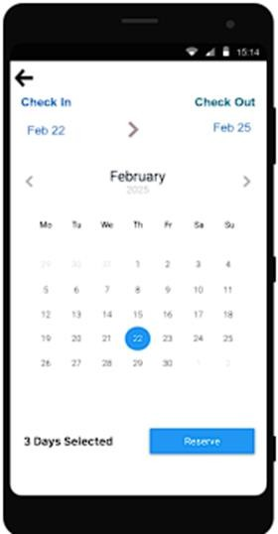

Familiar Icons:
- Back Arrow (←) - Top Left Corner:
  - A widely recognized navigation icon.
  - Clicking it will take the user back to the previous screen.

Left & Right Arrows (⟵ ⟶) - Near the Month Name (February 2025):
  - These are used to navigate between months in the calendar.
  - Clicking them allows users to select different check-in and check-out dates.

Calendar View with Highlighted Date (22):
  - A standard UI element in booking applications.
  - The selected date is highlighted, indicating the user's check-in/check-out selection.

"Reserve" Button - Bottom Right:
  - A common call-to-action (CTA) button.
  - Clicking it likely confirms the selected dates for booking.

Screen 8:
Confirmation page:
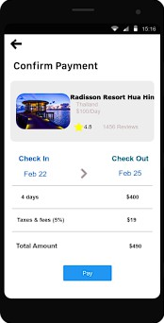

Familiar Icons:
- Back Arrow (←) - Top Left Corner:
  - A common navigation icon used in almost all mobile apps.
  - Clicking it will take the user back to the previous screen.

Star Icon (⭐) - Rating Indicator:
  - Represents the rating of the resort (4.5 stars).
  - A familiar UI element used in travel, e-commerce, and review-based apps.

Payment Button ("Pay") - Bottom Center:
  - A standard call-to-action (CTA) button used for confirming transactions.
  - Clicking it will likely redirect the user to a payment gateway.

Left & Right Arrows (⟵ ⟶) - Between Check-in and Check-out Dates:
  - Used for navigation between different date options.
  - Clicking these might allow the user to modify their selection.

Screen 9:

Payment confirmation Page:
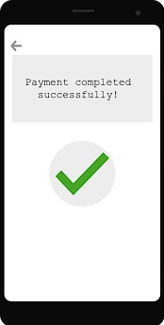
Prototype Link: https://pr.to/JIEKAF/

